Johnson & Wales
International Travel Registry Manual

To Register on the Travel Registry site
JWU Students and Faculty
Any person who has a student or faculty account at JWU will initiate their new account with LOGIN/REGISTER and can use their single sign-on JWU credentials.

- Go to http://studyabroad.jwu.edu/?go=InternationalTravelRegistry
(Also accessible via the Left hand navigation bar at studyabroad.jwu.edu: ‘Faculty and Advisors’ > Travel Registry > Register Your Travel Now)
- Click
- Select I have a JWU ID username and password. Click Submit.
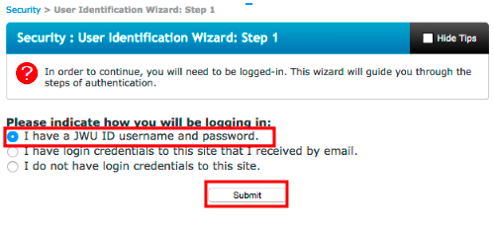
- Login with your JWU Credentials
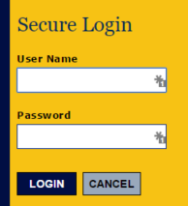

JWU Staff
Any person who is strictly staff at JWU will initiate their new account with NON-JWU LOGON/REGISTER because the HR database does not share information with the Travel Registry data management system. As a result, in this case, your JWU single sign-on credentials will not be recognized and you will be prompted through several steps to create an account.

- Go to http://studyabroad.jwu.edu/?go=InternationalTravelRegistry
(Also accessible via the Left hand navigation bar at studyabroad.jwu.edu: ‘Faculty and Advisors’ > Travel Registry > Register Your Travel Now)
- Click
- Select ‘I do not have login credentials to this site’ 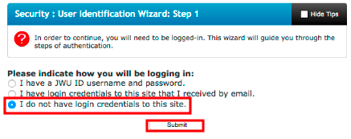
- Fill out the New User form. Under ‘Choose Institution’, select ‘Rhode Island’ and then select
‘---Other/Not found---‘
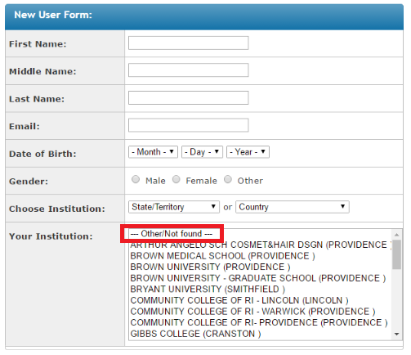

- Then type in ‘Johnson and Wales University’ and click ‘Create Account’. Once filled out, an email will be sent to you with your login and temporary password.
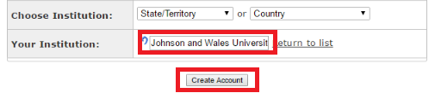
- Then type in ‘Johnson and Wales University’ then click ‘Create Account’
- Retrieve the temporary password from your email. Click the link in the email that will redirect you to login to the registration.
- Select the option, ‘I have login credentials to this site that I received by email.’
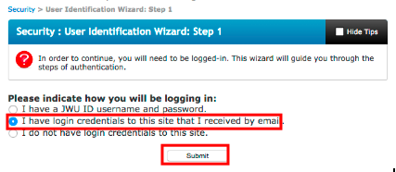

- Type in the login information from the email.

To Submit a Travel Registration
- Go to http://studyabroad.jwu.edu/?go=InternationalTravelRegistry
(Also accessible via the Left hand navigation bar at studyabroad.jwu.edu: ‘Faculty and Advisors’ > Travel Registry > Register Your Travel Now)
- Click ‘Register Your Travel’
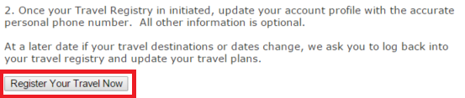
- Choose the appropriate login option > Submit
JWU travelers:
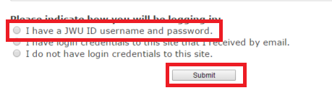

Non-JWU travelers:
- For JWU registrants ONLY: Log in with your JWU credentials
- Complete the form
**To add an itinerary, choose your dates and location then be sure to click ‘Add to Itinerary’
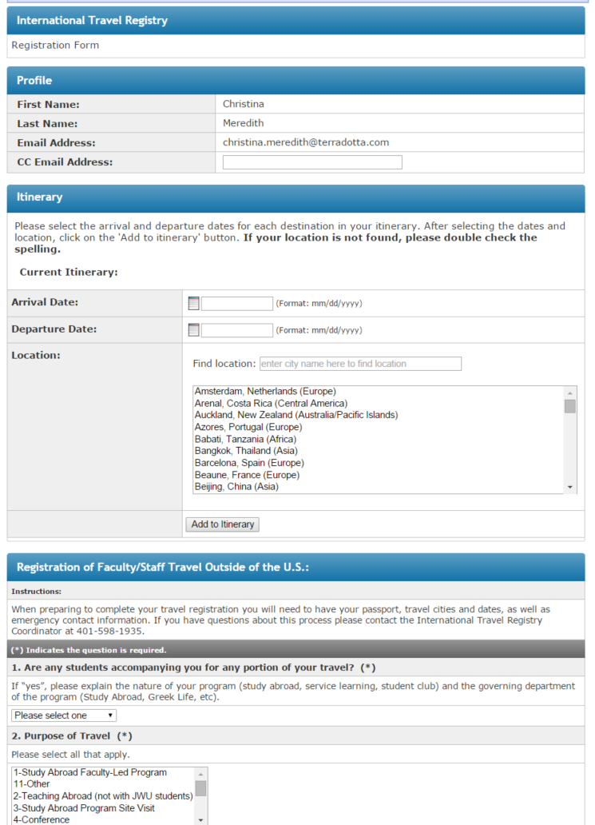

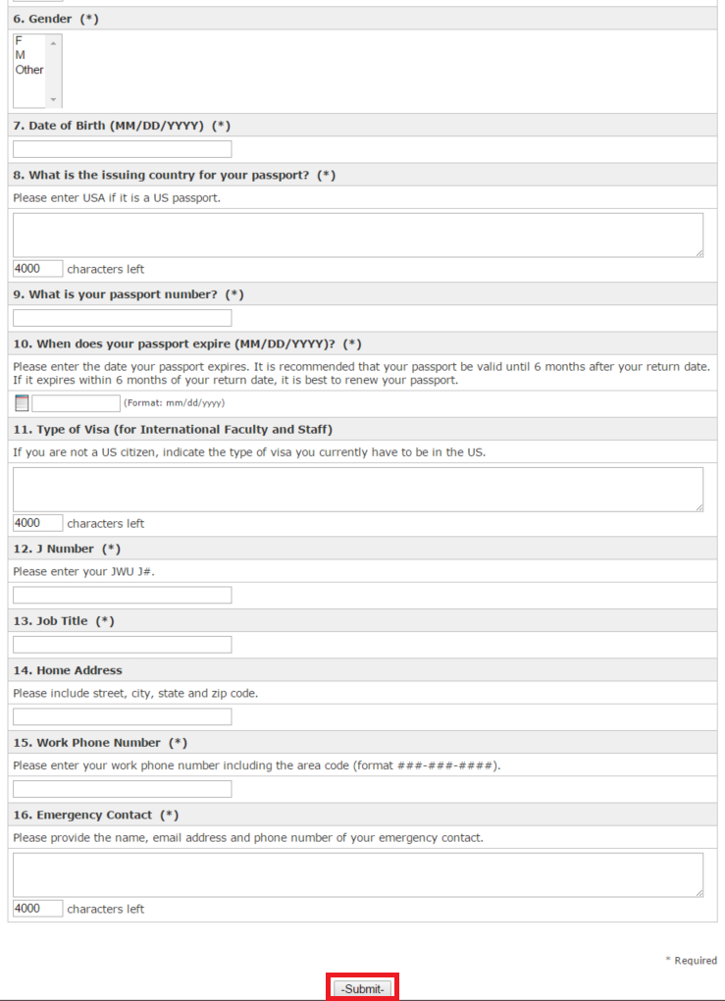

To Access Your Travel Registration
- Login in with JWU credentials by after clicking ‘LOGIN/REGISTER’ at http://studyabroad.jwu.edu.
- Click ‘International Travel Registry’ in the ‘Applications’ section
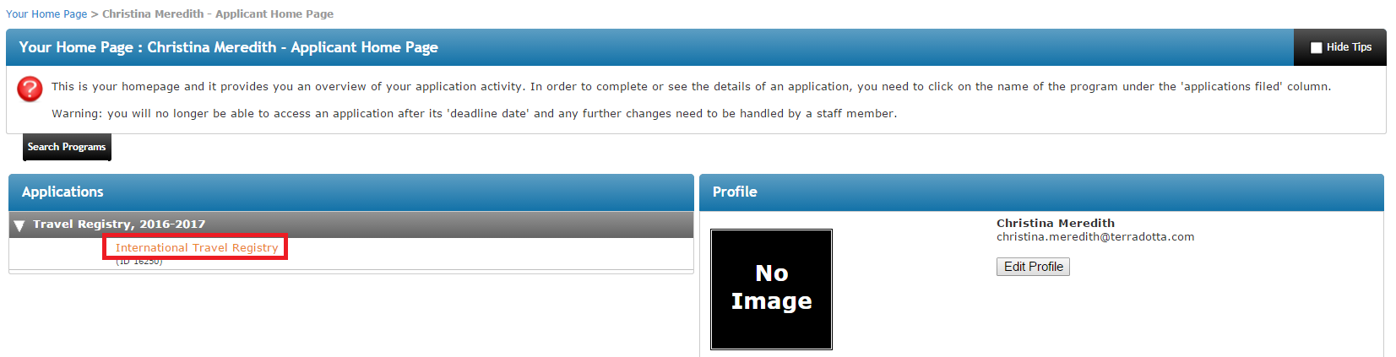
- Edit/Add information as necessary
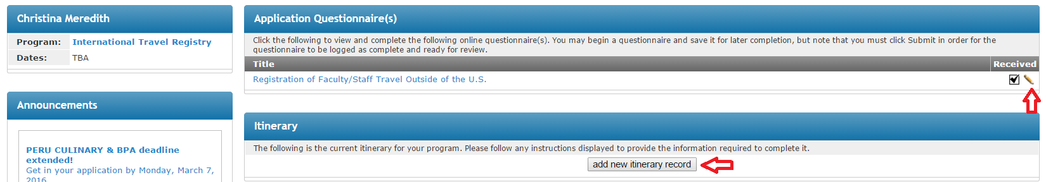

*Pencil icon edits the registration form
*’Add new itinerary record’ lets you add a new itinerary to this particular travel registration

